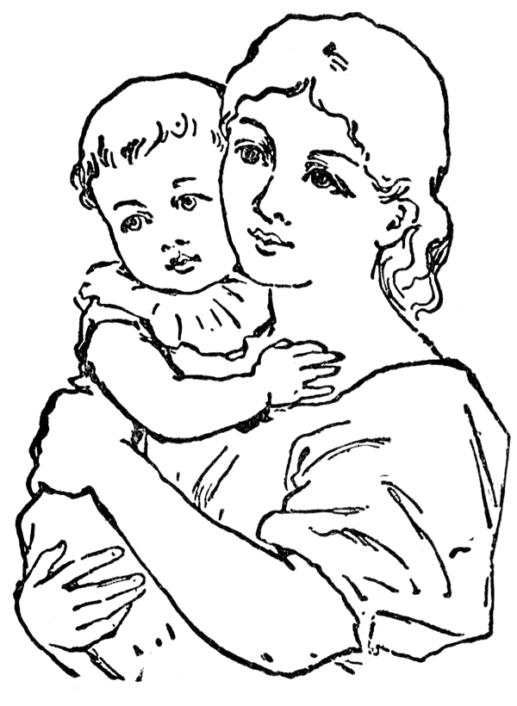
Bastardy Examination
Parish

At (Court Location and Date)
(Claimant v Defendant)

(Body of Text here)

(Outcome Recorded here).
Source:- (Reference) - (Book Source) (Date Range)

